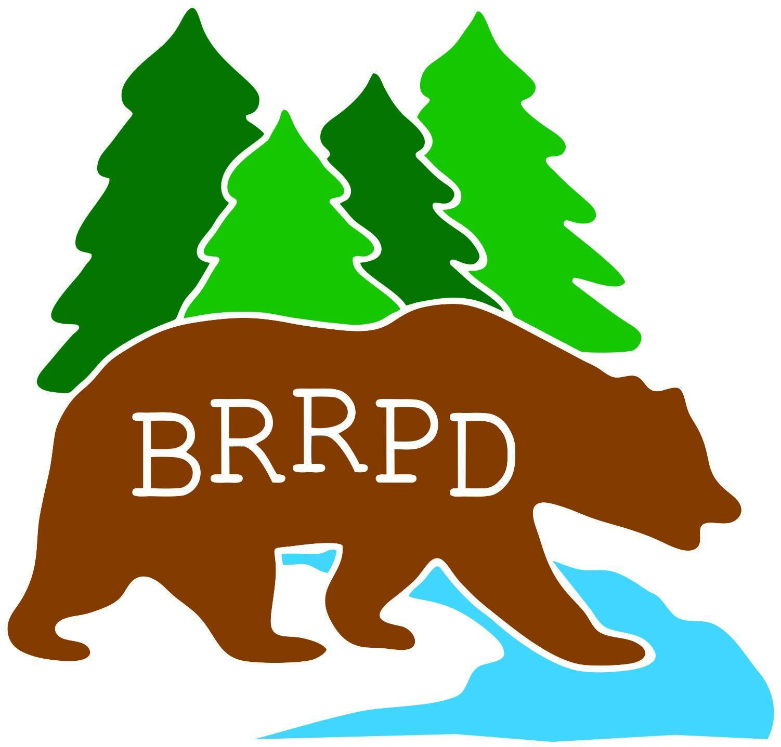

AGENDA FOR
REGULAR MEETING OF THE BOARD OF DIRECTORS
Tuesday, May 28, 2024– 4:30 P.M.
Office Board Room: 22431 Kingston Lane, Grass Valley, CA 95949
BOARD MEETIING WILL BE HELD in person and VIA ZOOM. VISIT OUR WEBSITE FOR ZOOM LOG IN INFO AND LINK TO THE MEETING
Board of Directors; Jessica Lee, Chair; Ed Downs, Vice Chair; Lori Godfrey, Board Member, Tanner Mathias , Board Member, Cindy Latimer, Board Member. . Staff; Miranda Brown General Manager; Maggie O’Callaghan, Program Coordinator. Adina Newberry; Board Secretary/ Office Manager.
ANY MEMBER OF THE AUDIENCE DESIRING TO ADDRESS THE DISTRICT BOARD ON A MATTER ON THE AGENDA: After receiving recognition from the Chair, please give your name, address, and the name of the organization you represent (if applicable) & state your comments or questions clearly. In order that all interested parties may have an opportunity to speak, please limit your comments to the specific matter under discussion. Time limits shall be at the Chair's discretion. An interpreter for the deaf or hearing impaired will be made available for this meeting upon 72 hours’ notice to the Bear River Recreation and Park District Office; 268-7275.
THE DISTRICT BOARD OF DIRECTORS MAY ACT UPON ALL ITEMS ON THE CONSENT AND ACTION PORTIONS OF THE AGENDA.
1. Call to Order
2. Pledge of Allegiance
3. Recognize guest in attendance
4. Financial Review (current monthly and YTD)
5. Approval of March and Aprils MM
6. Cascade Crossings BYLY Presentation
7. Gary Clark Field
8. Audit update
9. Personnel Committee -Jessica and Miranda
10. Safety Committee - Miranda and Vanessa
11. Finance Committee -Adina and Lori
12. Youth Skateboarding League Program update from Ed
13. BR Pool MOU Update
14. Scholarship - $400
15. Programs report to review
16. SCI Consulting Group for Cascade Crossings
17. District and Commission signature authority.
18. Resolution 052824

General Managers Report:
Program status:
ELO-P ends 5/31
BRRPD Summer Day Camp. Basketball, Tennis, Flag Football, Water Polo, Pool will be open all summer.
Safety Committee The Board of Directors acts as the District Safety Committee.
The Safety checklist will be done weekly by BRRPD staff and turned into GM the last day of every
month.
Comments and questions from guest
END REGULAR SESSION
PUBLIC COMMENT: MEMBERS of the public may make comments at this time on any items not appearing on the agenda that are of interest to the public and are within the jurisdiction of the Commission, provided that no action shall be taken unless otherwise authorized by Section 54954.2 of the Ralph M. Brown Act.

***************************CLOSED SESSION******************************

Next regularly scheduled meeting is Tuesday June 25th , 2024, 4:30 pm. Live and Via Google Meet
BEAR RIVER RECREATION & PARK DISTRICT
MAIL: 10042 Wolf Road, Suite B #11 Grass Valley, CA 95949
OFFICE: 22431 Kingston Lane Room 8, Grass Valley CA, 95949
Phone: 530. 268. 7275 Email: managerbrrpd@gmail.com : www.brrpd.org

