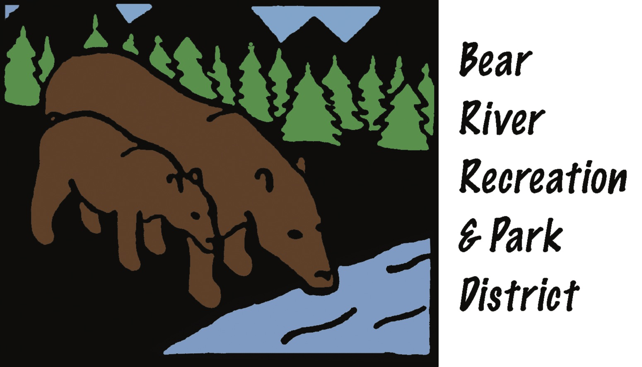
AGENDA FOR
REGULAR MEETING OF THE BOARD OF DIRECTORS
Thursday, November 16, 2017 – 6:00 P.M.
Board of Directors; Debi Juric, Chair; ___________Vice Chair; Scott Leaman, Board Member; Terry Eberhardt, Board Member;_____________, Board member.
General Manager; Marlene Sharon; Bookkeeper: Adina Herrlin

ANY MEMBER OF THE AUDIENCE DESIRING TO ADDRESS THE DISTRICT BOARD ON A MATTER ON THE AGENDA: After receiving recognition from the Chair, please give your name, address, and the name of the organization you represent (if applicable), & state your comments or questions clearly. In order that all interested parties may have an opportunity to speak, please limit your comments to the specific matter under discussion. Time limits shall be at the Chair's discretion. An interpreter for the deaf or hearing impaired will be made available for this meeting upon 72 hours notice to the Bear River Recreation and Park District Office; email only: brrpd@nccn.net

THE DISTRICT BOARD OF DIRECTORS MAY ACT UPON ALL ITEMS ON THE CONSENT AND ACTION PORTIONS OF THE AGENDA.

1. Call to Order
2. Pledge of Allegiance
3. Approval Items
a. Approval of Minutes from Board Meeting of September, 2017; No October Meeting
b. Approval of Current Payables, 2017
Reports and Action Items:
4. Interview and/or Appointment of Board Member to Fill Vacancy - Action
5. NEVCO Payment Process Update #2 - Report - AH
6. Annual Tax Levy - Report - MS
7. Auditor's Report 2016-17 - Board copies to review for December 21st Meeting Management Analysis-Report 8. Quarterly Safety Committee Acting as the Safety Committee, the Board will review and discuss any item in regards to safety of staff, patrons, facilities and equipment.
FOCUS: Gary D. Clarke Turf Field
9. New Business - December Holiday Party
10. Old Business - Board Area of Responsibilities, 501c3 Friends of BRRPD, other
General Manager Report:
A. Field Maintenance
C. CPRS Champion of the Community Nomination - Jay Adamson
D. Delinquent Properties Bids - November 9th-13th - Nevada County Auction
E. Cascade Crossings Community Meeting - October 28th 10:00 a.m. Office

PUBLIC COMMENT: MEMBERS of the public may make comments at this time on any items not appearing on the agenda that are of interest to the public and are within the jurisdiction of the Commission, provided that no action shall be taken unless otherwise authorized by Section 54954.2 of the Ralph M. Brown Act.

The next meeting of the Board will be held on Thursday, December 21st. This meeting will be held at the new location at the BRRPD Office, #110 Lake Center Plaza 10988 Combie Road.

BEAR RIVER RECREATION & PARK DISTRICT
Mail: .10042 Wolf Road, Suite B, PMB #11, Grass Valley, CA 95949
Office: Lake Center Plaza, 10988 Combie Road, #110
Phone: 530-268-7275 Email: brrpd@nccn.net Web: bpprd.org

